Evidence Output

T006:

Valid date of birth.

Input number 11/11/199777.

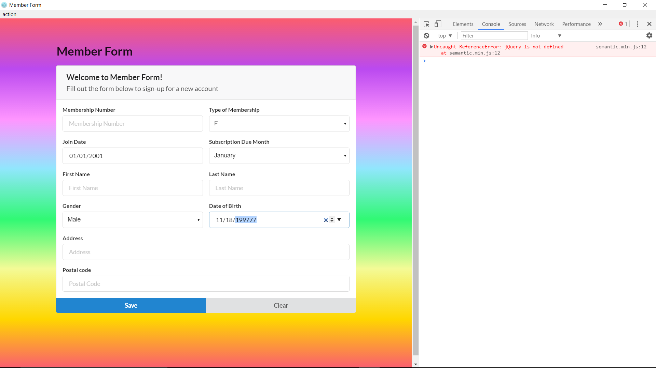

Valid date of birth fail.

